***Aim***: The principal objective of your website should always be to attract customers to your restaurant and as such an online booking function is the most essential feature. This may lead to another page with your restaurant's opening times and telephone number for those wanting to make reservations by phone.

***Objective***: The purpose of a restaurant website is to help customers choose you over other eateries. If you include the above features, you make it easier for diners to choose you.

***Theory***:

A restaurant’s web plan summary should seek to establish a website that meets the desired navigational and end-user thresholds. For example, a simple home page design with tabs linking the restaurant’s profile page, food menu, drinks, events, locations, contacts and sign-up link would provide easy access to the main segments of the website. A user-friendly restaurant website would also have visible links for additional features such as online ordering, payment options, delivery and outside catering. Moreover, the focus of the restaurant web plan should be directed toward the creation of a marketable, dynamic and interactive website capable of responding to changes in customers’ food and drink preferences. For example, the integration of cookies would be helpful in tracking, profiling and customizing customers’ search preferences for different drink and food items.

A vision statement outlines the purpose behind building your restaurant website. This includes the intended audience for the site, the principles that support the endeavor and the priorities for those principles. The vision statement also allows web developers to ensure that any future improvements in the site's design, functionality and content will line up with the site's mission. For instance, the vision statement should make clear if the site's purpose is to deliver customer information or to improve internal processes.

The functional capabilities of a restaurant’s website vary by its integrative features. For example, a website with an interactive food/drink ordering system and integrated online payment platform will have greater functionality than a website used solely for disseminating menu and contact information. Additional functionalities, such as live chat portals and web maps, expand the scope of a website’s profile as well. An ideal web plan summary seeks to integrate as many functional features as possible with a view of accelerating the sale of a restaurant’s meals, drinks and special offers such as candlelit dinners.

***Code***:

**Index Code**:

<!DOCTYPE html>

<html lang="en">

<head>

<meta charset="UTF-8">

<meta http-equiv="X-UA-Compatible" content="IE=edge">

<meta name="viewport" content="width=device-width, initial-scale=1.0">

<meta name="description" content="Welcome to the unique and luxurious hotel in Surat">

<script src="https://kit.fontawesome.com/b1fe0a4626.js" crossorigin="anonymous"></script>

<meta name="keywords" content="hotel,Surat ">

<link rel="stylesheet" href="css2/style2.css">

<title>Hotel | Welcome</title>

</head>

<body>

<header>

<nav id="navbar">

<div class="Container">

<h1 class="logo"><a href="index.html">TGB</a></h1>

<ul>

<li><a class="current" href="index.html">Home</a></li>

<li><a href="about.html">about</a></li>

<li><a href="contact.html">contact</a></li>

</ul>

</div>

</nav>

<div class="showcase">

<div class="Container">

<div class="showcase-content">

<h1><span class ="text-primary">Enjoy</span> the stay!</h1>

<p class="lead">Set in the heart of Surat!!Located along Tapi River, Surat The grand budapest Hotel features an outdoor pool, spa,free WI-FI ,Training gym center and many other.Free parking is provided too.

</p>

<a class="btn" href="about.html">happy to introduce</a>

</div>

</div>

</div>

</header>

<section id="home-info" class="bg-dark">

<div class="info-img"></div>

<div class="info-contact">

<h2>History of<span class="text-primary"> The Grand budapest hotel</span></h2>

<p>Opened in 1896 with 350 rooms,

the Grand Hotel Royal was one of Asia's largest hotels at the time,

and most definitely one of the most luxurious,

too, just like another fictional hotel.

The hotel had the ability to cater to 400 guests

and employed 200 staff to cater to their whims and needs.</p>

<a href="about.html" class="btn btn-light">Read more</a>

</div>

</section>

<section id ="features">

<div class="box bg-light">

<i class="fas fa-hotel fa-3x"></i>

<h3>Location</h3>

<p>The setting of this beautiful indigenous village-style hotel with its private view is spectacular, with dramatic Haunted dumas beach on one side. Palace is located in the middle of valley.The property has housed royalty in the past</p>

</div>

<div class="box bg-primary">

<i class="fas fa-utensils fa-3x"></i>

<h3>Food</h3>

<p>With three restaurants, two bars, a coffee shop and 24-hour room service, you can eat and drink around the clock at The grand budapest hotel.Abhay padavi Award-winning master-chief is behind the brunch and dinner in restaurant with unlimited meals. </p>

</div>

<div class="box bg-light">

<i class="fas fa-dumbbell fa-3x"></i>

<h3>Fitness room</h3>

<p>It has special rooms for power lifters to ensure they do not have any distraction during practice.The Gym trainers are assist the members in all possible ways to help them reach their fitness goals.The atmosphere offers freedom and supports one to be their best with fitness.</p>

</div>

</section>

<div class="clr"></div>

<footer id="main-footer">

<p>The Grand budapest hotel &copy; 2021 ,All rights reserved</p>

</footer>

</body>

</html>

**Contact Code**:

<!DOCTYPE html>

<html lang="en">

<head>

<meta charset="UTF-8">

<meta http-equiv="X-UA-Compatible" content="IE=edge">

<meta name="viewport" content="width=device-width, initial-scale=1.0">

<meta name="description" content="Welcome to the unique and luxurious hotel in Surat">

<script src="https://kit.fontawesome.com/b1fe0a4626.js" crossorigin="anonymous"></script>

<meta name="keywords" content="hotel,Surat ">

<link rel="stylesheet" href="css2/style2.css">

<title>Hotel | Contact</title>

</head>

<body>

<header>

<nav id="navbar">

<div class="Container">

<h1 class="logo"><a href="index.html">TGB</a></h1>

<ul>

<li><a href="index.html">Home</a></li>

<li><a href="about.html">About</a></li>

<li><a class="current" href="contact.html">Contact</a></li>

</ul>

</div>

</nav>

</header>

<section id="contact-form" class="py-3">

<div class="container">

<h1 class="l-heading"><span

class="text-primary">Contact</span> Us</h1>

<p>Please fill out the form below to contact us!</p>

<form action="process.php">

<div class="form-group">

<lebel for="name">Name</lebel>

<input type="text" name="name" id="name" placeholder="Enter name">

</div>

<div class="form-group">

<lebel for="email">Email</lebel>

<input type="email" name="email" id="email" placeholder="Enter email">

</div>

<div class="form-group">

<lebel for="message">Message</lebel>

<textarea name="message" id="message" placeholder="any message"></textarea>

</div>

<button type="submit"value="send" class="btn bg-dark">Submit</button>

</form>

</div>

</section>

<section class="contact-info">

<div class="container">

<div class="box">

<h3>Location</h3>

<p>Surat,Gujarat</p>

</div>

<div class="box">

<h3>Phone number</h3>

<p>9558538691</p>

</div>

<div class="box">

<h3>Email</h3>

<p>abhaypadavi@gmail.com</p>

</div>

</div>

</section>

<footer id="main-footer">

<p>The Grand budapest hotel &copy; 2021 ,All rights reserved</p>

</footer>

</body>

</html>

**About Code**:

<!DOCTYPE html>

<html lang="en">

<head>

<meta charset="UTF-8">

<meta http-equiv="X-UA-Compatible" content="IE=edge">

<meta name="viewport" content="width=device-width, initial-scale=1.0">

<meta name="description" content="Welcome to the unique and luxurious hotel in Surat">

<meta name="keywords" content="hotel,Surat ">

<link rel="stylesheet" href="css2/style2.css">

<title>Hotel | About</title>

</head>

<body>

<header>

<nav id="navbar">

<div class="Container">

<h1 class="logo"><a href="index.html">TGB</a></h1>

<ul>

<li><a href="index.html">Home</a></li>

<li><a class="current" href="about.html">About</a></li>

<li><a href="contact.html">contact</a></li>

</ul>

</div>

</nav>

</header>

<section id="About-info" class="bg-light py-3">

<div class="Container">

<div class="info-left">

<h1 class ="l-heading">About<span class="text-primary"> TGB</span></h1>

<p>The Grand Hotel Royal was a community, more than just a hotel, with shops taking the “Royal” name.

The Grand Hotel Royal was, indeed, the most luxurious and advanced hotel of the Central Asian region.

it’s main entrance brings you in form the street,a surprising secret that allows guests to connect

from the hotel to the spa next door without having to step foot into the boulevard outside.

If you’re looking to get away with friends or family,then The grand budapest hotel could be a perfect

getaway and has all the luxurious you need from a hotel.From the bedroom, you have a spectacular view of fifth avenue.

So if you don’t feel like lounging around in bed all day, then you can make use of the 24-hour butler service the suite provides.

</p>

<p>

The grand budapest hotel is fully equipped with the ultimate in luxury, and everything you’d want from an experience you can have here.

This hotel has the ability to transport you to a relaxing high miles from the hustle and bustle of busy mind, despite being in the middle of Uptown.

The spa and pool make it hard to beat,the rooms and suites with incredible interior design and abundant natural light,via floor-to-ceiling windows.

</p>

</div>

<div class="info-right">

<img src="./815870.jpg" alt="hotel">

</div>

</div>

</section>

<div class="clr"></div>

<section id="testimonials" class="py-3">

<div class="container">

<h2 class="l-heading">Customer Reviews</h2>

<div class="testimonials bg-dark">

<img src="./20190331_112925.jpg" alt="Mahek">

<p>Fantastic meals! Pleasantly surprised:) Our stay at the budapest hotel was excellent. We stayed in the ground floor and the views

and sounds from the garden was splendid! Beyond relaxing atmosphere of the hotel, the next best part was the fantastic service at the

reception and thay gave us a very generous gift before leaving. The staff was very attentive, professional, and friendly😋.

</p>

</div>

<div class="testimonials bg-dark">

<img src="./1558234659320.jpg" alt="Surekha">

<p>This is my second time staying here. Last year we stayed here to celebrate our anniversary and we LOVED IT.

We agreed that every year,to celebrate our anniversary, we will be back to the same hotel. The smell of

lavender everywhere you go is so relaxing especially if you live in a busy city as Surat. The quality

or the service provided is worth every bills paid for.

</p>

</div>

</div>

</section>

<footer id="main-footer">

<p>The Grand budapest hotel &copy; 2021 ,All rights reserved</p>

</footer>

</body>

</html>

**CSS Code**:

#navbar .logo {

float:none;

text-align: center;

}

#navbar ul, #navbar ul li {

float:none;

}

#navbar ul li a {

padding:5px;

border-bottom:#444 dotted 1px;

}

/* home info */

#home-info .info-img {

display:none;

}

#home-info .info-content {

float: none;

width: 100%;

}

/* boxes */

.box {

float:none;

width:100%;

}

/* Reset */

* {

margin:0;

padding:0;

box-sizing: border-box;

}

/* main styling*/

html,body {

font-family: 'Times New Roman', Times, serif;

line-height: 1.6em;

}

a {

color:#333;

text-decoration: none;

}

h1,h2,h3 {

padding-bottom: 20px;

}

p {

margin: 10px 0;

}

/* utilitiy classes */

.Container {

margin:auto;

max-width:1100px;;

overflow:auto;

padding: 0 20px;

}

.text-primary {

color:darkmagenta;

}

.lead {

font-size: 20px;

}

.btn {

display: inline-block;

font-size:18px;

color: #f777f7;

background: #333;

cursor:pointer;

border:none;

}

.btn-light {

background: #f4f4f4;

color:#333;

}

.bg-light {

background:#f4f4f4;

color:#333;

}

.bg-dark {

background: #333;

color:#fff;

}

.bg-primary {

background:#f777f7;

color: #333;

}

.clr {

clear:both;

}

.btn:hover {

background: #f777f7;

color:#333;

}

.hadding-l {

font-size: 40px;

}

/* padding */

.py-1 { padding:10px 0;}

.py-2 { padding:20px 0;}

.py-3 { padding:30px 0;}

/* navbar */

#navbar {

background:#333;

color:#fff;

overflow: auto;

}

#navbar a {

color:#fff;

}

#navbar h1 {

float: left;

padding-top:20px;

}

#navbar ul {

list-style: none;

float:right;

}

#navbar ul li {

float:left;

}

#navbar ul li a {

display: block;

padding:20px;

text-align: center;

}

#navbar ul li a:hover,

#navbar ul li a.current {

background: #444;

color:darkmagenta;

}

/* showcase */

.showcase {

background: url('../760735.jpg')

no-repeat center center/cover;

height: 400px;

}

.showcase .showcase-content {

color:black;

text-align: center;

padding-top:170px;

}

.showcase .showcase-content h1 {

font-size: 60px;

line-height: 1.2em;

}

.showcase .showcase-content p {

padding-bottom: 20px;

line-height: 1.7em;

}

/* Home info */

#home-info {

height: 400px;

}

#home-info .info-img {

float:left;

width:50%;

background: url('../347641.jpg') no-repeat center center/cover;

min-height: 100%;

}

#home-info .info-content {

float: right;

width: 50%;

height: 100%;

text-align: center;

padding:50px 30px;

overflow:hidden;

}

#home-info .info-content p {

padding-bottom: 30px;

}

/* features */

.box {

float:left;

width:33.3%;

padding:50px;

text-align: center;

}

.box i {

margin-bottom: 10px;

}

/* about info */

#About-info .info-right {

float:right;

width: 50%;

min-height: 100%;

}

#About-info .info-right img {

display: block;

margin:auto;

width:100%;

border-radius: 50%;

}

#About-info .info-left {

float:left;

width:50%;

min-height: 100%;

}

/* Testimonial */

#testimonials {

height:600px;

background: url('../362619.jpg') no-repeat

center center/cover;

padding-top:100px;

}

#testimonials .testimonials img {

width:50px;

float:left;

margin-right: 20px;

border-radius: 50%;

}

#testimonials .testimonials img p{

float:right;

}

#testimonials h2{

color:#fff;

text-align: center;

padding-bottom:40px;

}

#testimonials .testimonials {

padding:20px;

margin-bottom: 40px;

border-radius: 5px;

opacity: 0.9;

}

/* contact form */

#contact-form lebel {

display:block;

margin-bottom: 5px;

}

#contact-form input,

#contact-form textarea {

width:100%;

padding:10px;

border:1px #ddd solid;

}

#contact-form textarea {

height: 150px;

}

#main-footer {

text-align: center;

background: #444;

color:#fff;

padding:20px;

}

***Output***:

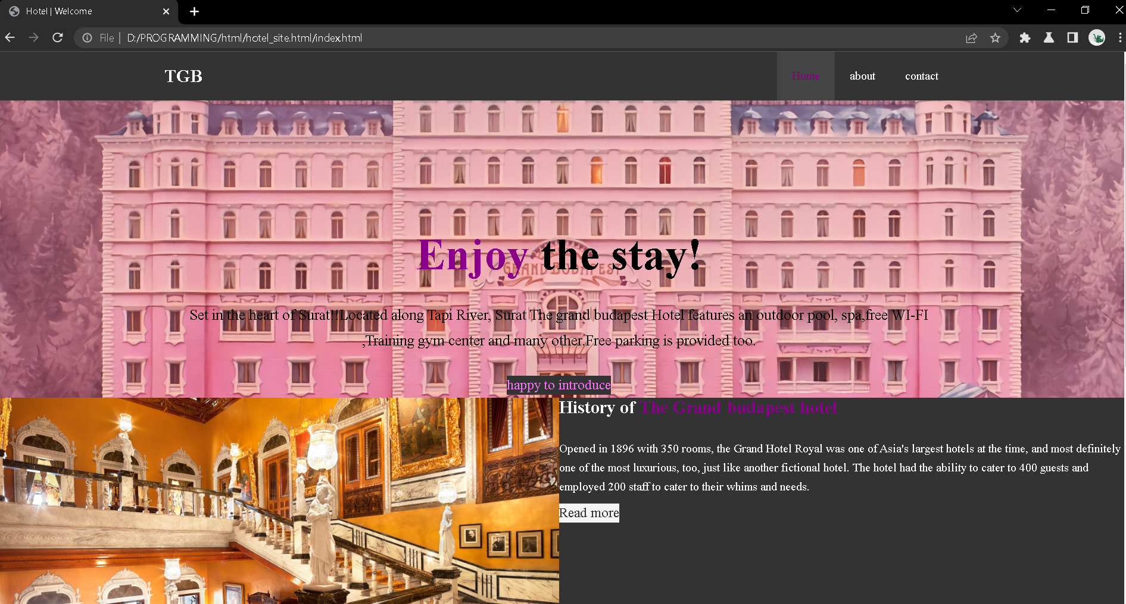

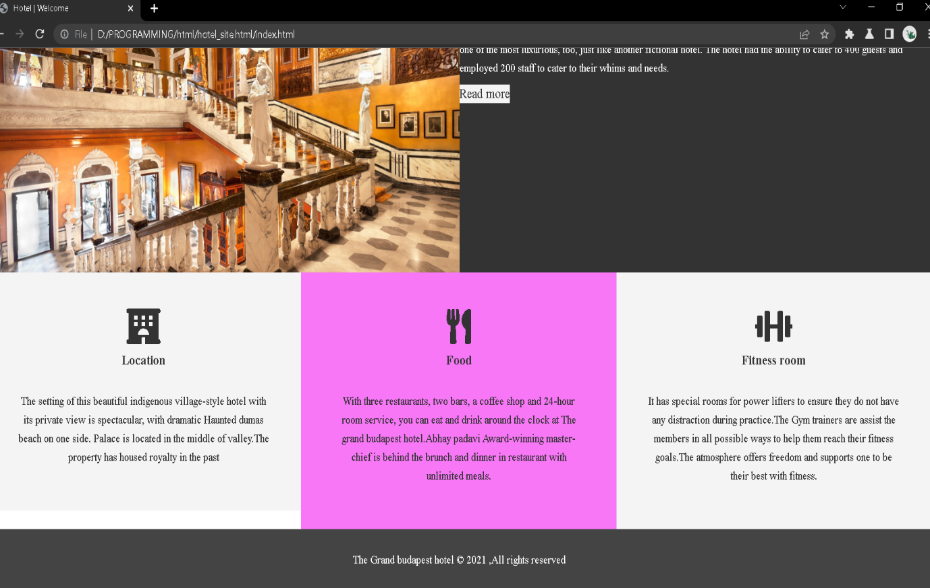

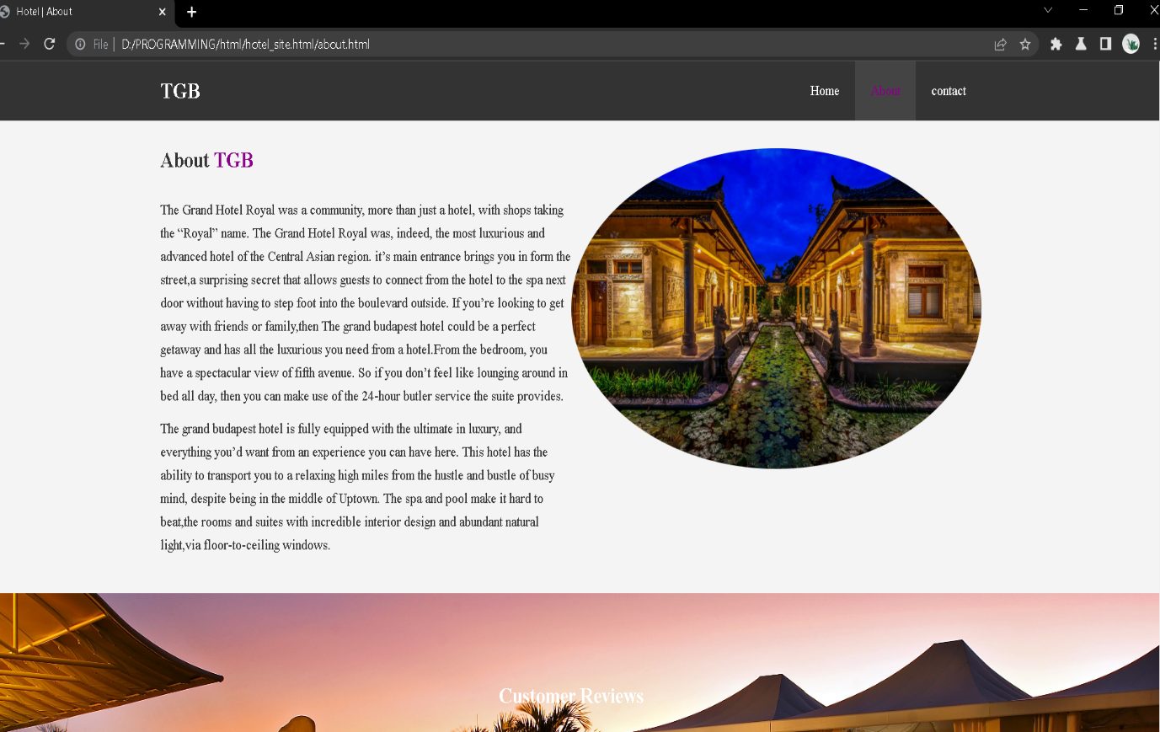

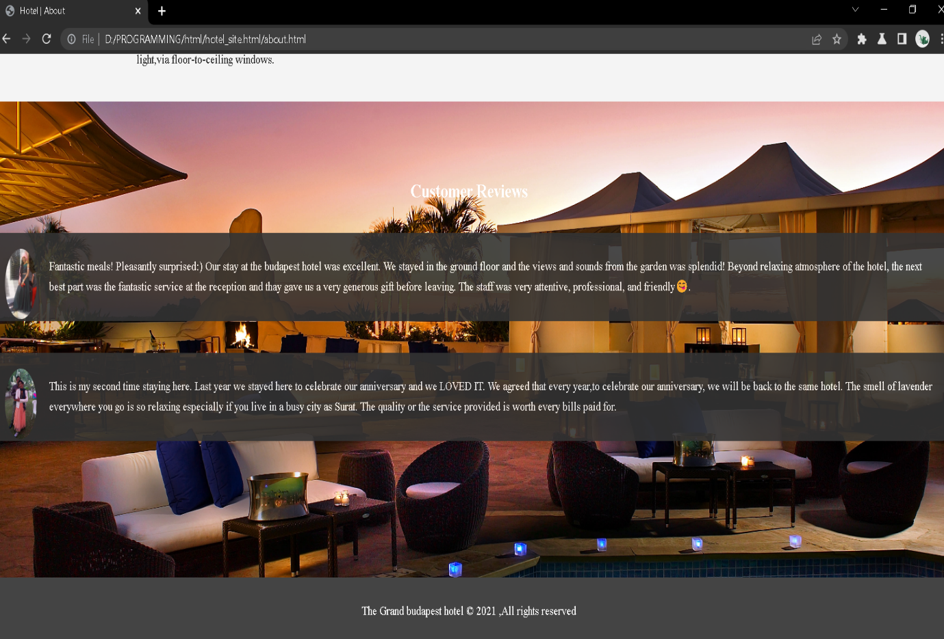

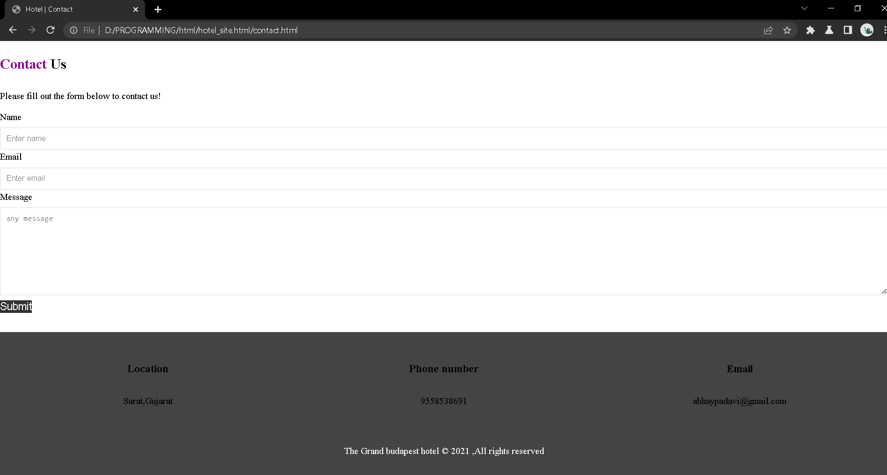

**Conclusion**: Attention to detail is the most important concept in developing a restaurant. Proper planning and creativity can make the rest of your concept come easy. Once you have a vision of your establishment, you can begin to focus on the menu, staffing needs and other requirements.